DESIGN AND INTEGRITY ASSURANCE OF PRESSURE VESSELS FOR STORING HYDROGEN
Ashok Saxena¹*, Amit Prakash², and Ian Miller³
¹University of Arkansas, Fayetteville, AR, USA, ²Wiretough Cylinders, LLC, Bristol, VA, USA
³N&R Engineering, Cleveland, OH, USA
* Presenting Author email: asaxena@uark.edu
Abstract
Cost-effective, pressure vessels for use in hydrogen refueling stations require vessels that can safely store up to 750 liters of gaseous hydrogen at 1000 bars or 90 MPa. This paper uses fracture mechanics analysis to assist in the design and structural integrity of a Type 2 pressure vessel to meet this need utilizing a time-tested metal liner and a high strength steel wire overwrap.
- Introduction
Metal cylinders have been used for storing hydrogen for several decades but are limited to pressures of 55 MPa due to hardenability of the material and the ability to reliably inspect for flaws. The designs must also meet safety requirements of standards such as the ASME PVP Section VIII- Division 3 codes. Using the time-tested, metal cylinders as liners and wrapping them with high strength steel wires that are 2 GPa or higher in strength is an effective approach for doubling the pressure capability of these metal composite cylinders. The wire-wrapped cylinders are further subjected to an autofrettage process in which they are subjected to pressures high enough to plastically deform the inner liner, but the wire jacket remains elastic. Upon release of the autofrettage pressure, the inner liner is left with high residual compressive hoop stresses. This process decreases the maximum tensile hoop stress in the liner under the operating pressure and can thus enhance the fatigue life of the vessel very significantly. This paper describes the concurrent use of nonlinear finite element analysis, fracture mechanics analysis, and optimization of non-destructive inspection techniques to expediently meet both the design safety and commercial requirements.
- Results
Finite element (FE) analyses were performed to conduct sensitivity analyses in support the design as described below:
- Effect of varying orthotropic properties of the wrap on liner stresses was systematically explored and was shown to be not important in estimating stresses in the cylinder.
- The effects of varying wire pre-tension load from 17.8 to 35.6 N (4 to 8 lbs) on the maximum stress in the liner wall was investigated. It was shown that increasing the wire pre-tension load did not significantly affect the maximum wall stress on the inside surface of the liner.
- Extending the wrap to the transition point between the cylinder body and the head leads to a stress reduction. Extending the wrap onto the head provides even a greater stress reduction. Further reductions in maximum stress are possible by reinforcing a portion of the dome with carbon fiber composite.
- Reducing yield strength of the liner material was shown as an effective means of reducing the stress in the critical region. Liner material with a lower yield strength allows for a lowering the autofrettage pressure that is desirable from a manufacturing view.
Effect of hydrogen on the fatigue crack growth rate behavior in the liner material was investigated to support the fracture mechanics calculations. The service loading conditions include negative load ratios so fatigue crack growth rate data were generated for negative load ratios, R. A single-edge-crack-tension specimen, SEC(T), to obtain this data was developed and tests were conducted at -1.0 ≤ R ≤ 0.2. The hydrogen pressure during these tests was approximately 10 MPa. Tests were also performed under constant ΔK conditions to explore the effects of cyclic frequencies between 0.001 and 6 Hz on the FCGR behavior in H₂. The results of the testing are shown in Fig. 1. There appear to be no be no systematic effects of frequency so tests at 1 Hz appear to provide representative conditions for assessing crack growth behavior of the liner materials at all frequencies. Similarly, the differences between the FCGR behavior in H₂ pressures of 10 MPa and 100 MPa were addressed using literature data at R values of 0.1 and 0.2 and the behavior was found to be comparable. The above data were used in a crack growth calculation to estimate design lives of wire wrapped storage cylinders containing SA 372 metal liners.
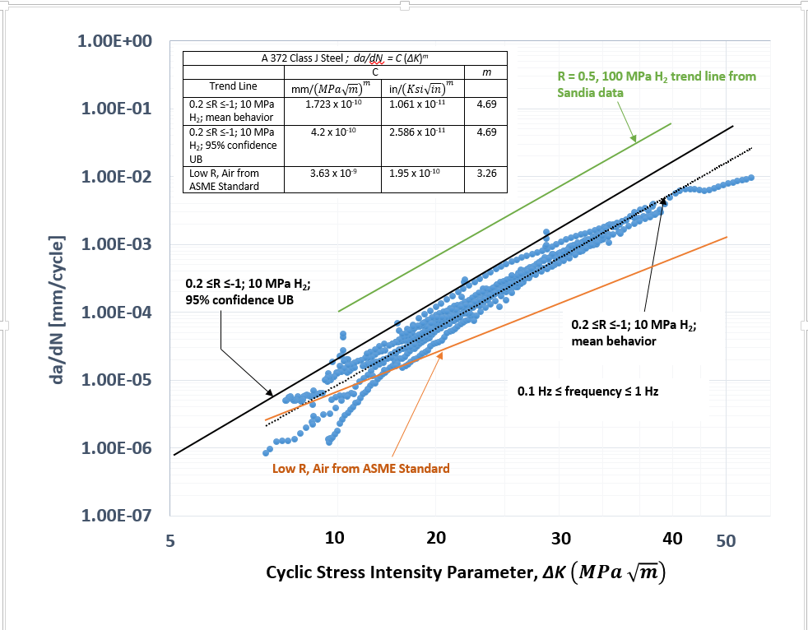
Fig.1 – FCGR behavior of SA372 in H₂ at pressure of 10 MPa and -1.0 ≤ R ≤ 0.2.
Initial flaw sizes assumed for the above calculations were (i) based on the currently used nondestructive testing (NDT) capability that is said to reliably detect flaws that have a depth of 3% of the wall thickness or greater, and (ii) based on work performed as part of this project that showed that cracks that are 2% of the wall thickness or greater can also be reliably detected. The initial flaw length on the surface (2c) is taken as three times the depth, as per the ASME codes. The final crack size is assumed to be 0.25 of the wall thickness because of the high toughness of the steel used in the liners. For a stress level of 310 MPa (45 Ksi), design lives of 30,000 and 21,000 cycles were estimated for initial flaw sizes of 0.03 and 0.02 of the wall thickness, respectively. These number of cycles are sufficient for the design life of 30 years at 2 cycles/day.
- Conclusions
The approach of concurrently performing design and manufacturing optimization, integrity analyses that consisted of finite element analysis, fracture mechanics analysis, and re-evaluating the nondestructive evaluation (NDE) technique resulted in an economical design of a cylindrical tank for storing hydrogen at very pressure levels in a short period.
Acknowledgements
The financial support of the Department of Energy through their Office of Energy Efficiency and Renewable Energy (EERE) for this work through a contract to WireTough Cylinders, LLC is gratefully acknowledged. We acknowledge the direction of Dr. Katie Randolph, Project Manager and Neha Rustagi, Co-Project Manager.

